**IBM HACKATHON PROJECT**

## ECO FRIENDLY AI AGENT

**Presented By:**

**Student name : Raaga Lahari Sakethapuram**

**College Name : G Narayanamma Institute of Technology & Science (For Women)**

**Department : CSE (Data Science)**

**AICTE Student ID: STU6814c4ff8a3681746191615**

### OUTLINE

* **Problem Statement**
* **Technology used**
* **Wow factor**
* **End users**
* **Result**
* **Conclusion**
* **Git-hub Link**
* **Future scope**
* **IBM Certifications**

# PROBLEM STATEMENT

Individuals and communities striving to adopt a sustainable lifestyle often struggle to access reliable, personalized, and localized information on eco-friendly practices.

With the overwhelming volume of green living tips, product recommendations, and recycling rules scattered across sources, finding useful guidance becomes time-consuming and inefficient.

# PROPOSED SOLUTION

* An AI-powered Eco Lifestyle Agent using:
* - Retrieval-Augmented Generation (RAG)
* - IBM Granite Foundation Model
* - IBM Cloud Lite Services
* It provides:
* - Personalized sustainability tips
* - Local recycling guidelines
* - Eco product recommendations
* - Info on relevant government schemes
* Users ask in natural language and receive instant, actionable answers.

# TECHNOLOGY USED

* IBM Cloud Lite Services
* Watsonx.ai (Studio & Runtime)
* IBM Granite Foundation Models
* RAG Architecture

### IBM CLOUD SERVICES USED

* + Watsonx.ai Studio – Build and fine-tune RAG models
  + Watsonx.ai Runtime – Host and deploy the AI Agent
  + Agent Lab – Manage chatbot and integration
  + Granite Foundation Models – For natural language understanding

**WOW FACTORS**

* Personalized Sustainability Tips
* Local Recycling & Govt Schemes
* Semantic Search with RAG
* Real-time Green Recommendations
* Actionable Guidance, Not Just Information
* Habit tracking (future)
* Voice and multilingual support (future)

### END USERS

* + - Eco-conscious citizens
  + - Urban households
  + - Schools & universities
  + - NGOs promoting sustainability
  + - Local governments
  + - Event organizers (green events)

**RESULTS**

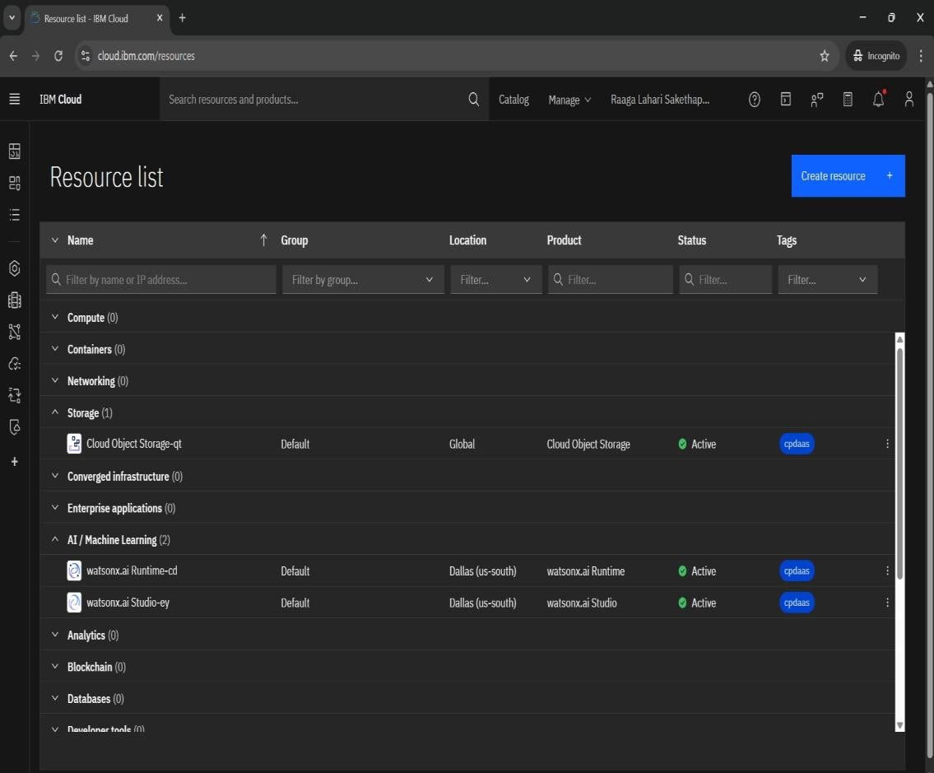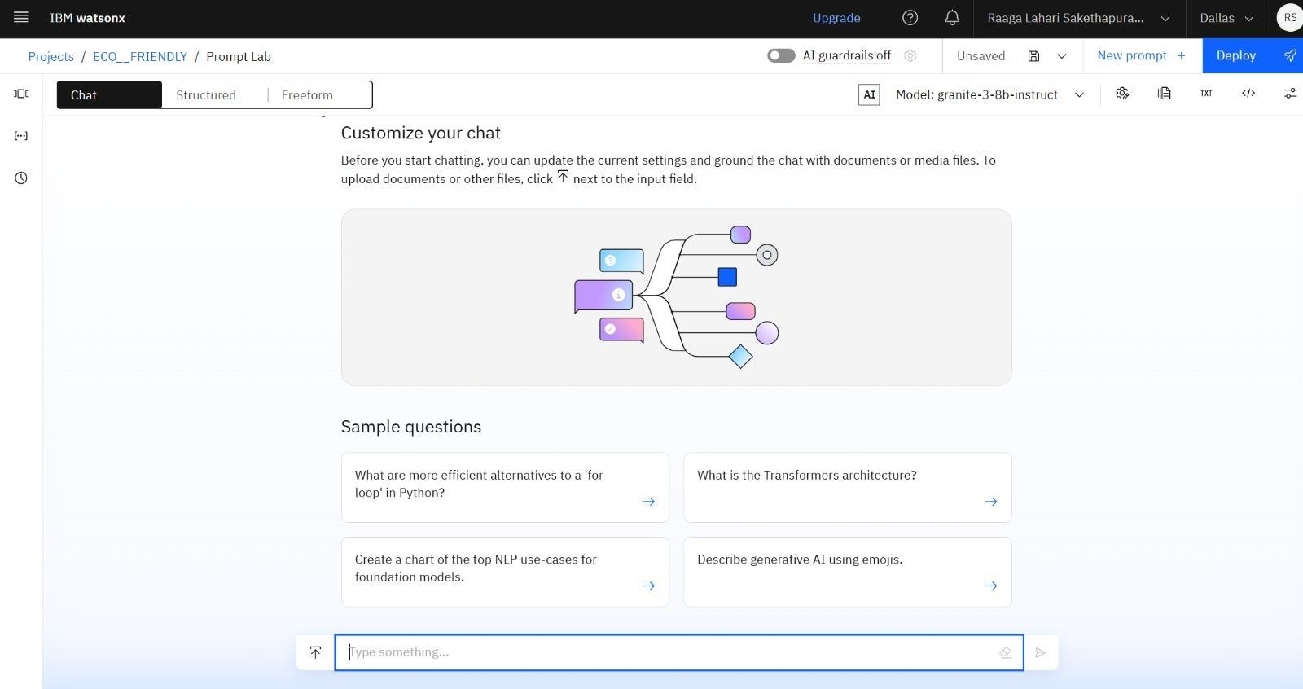

**RESULTS**

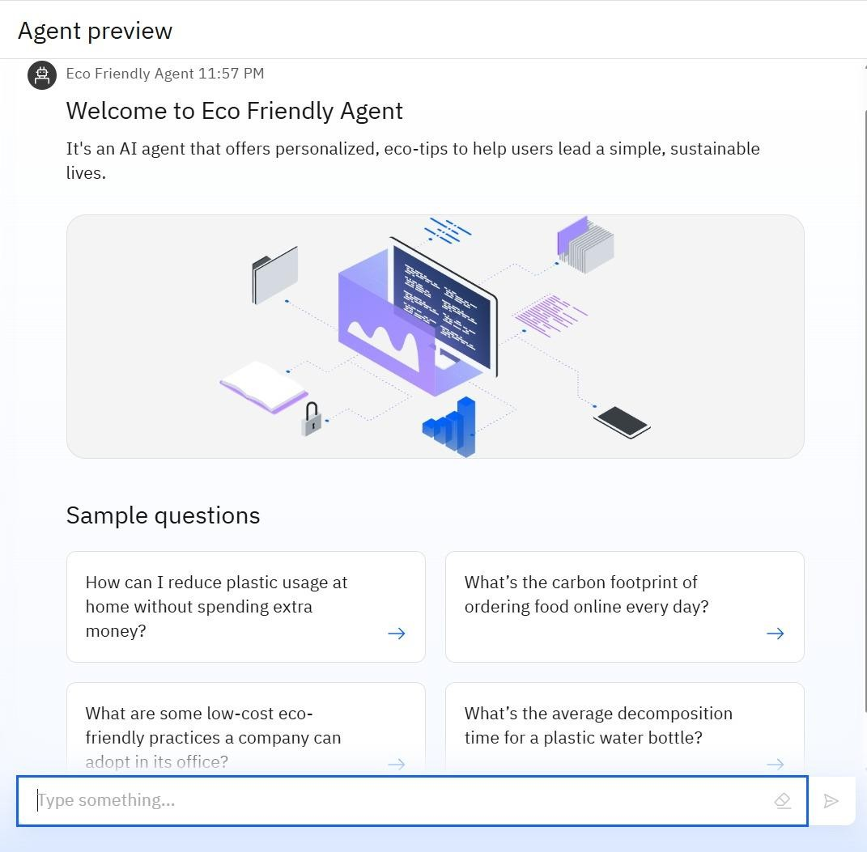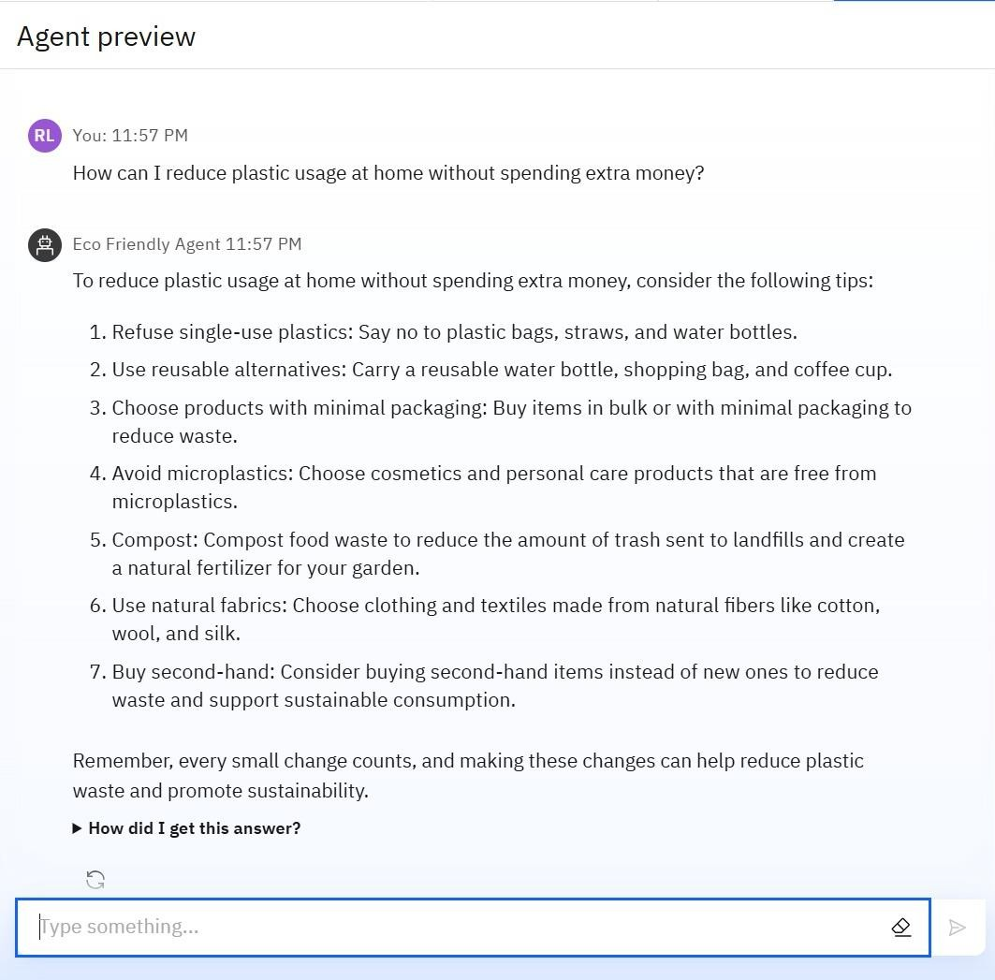

## RESULTS

DEPLOYED AI AGENT

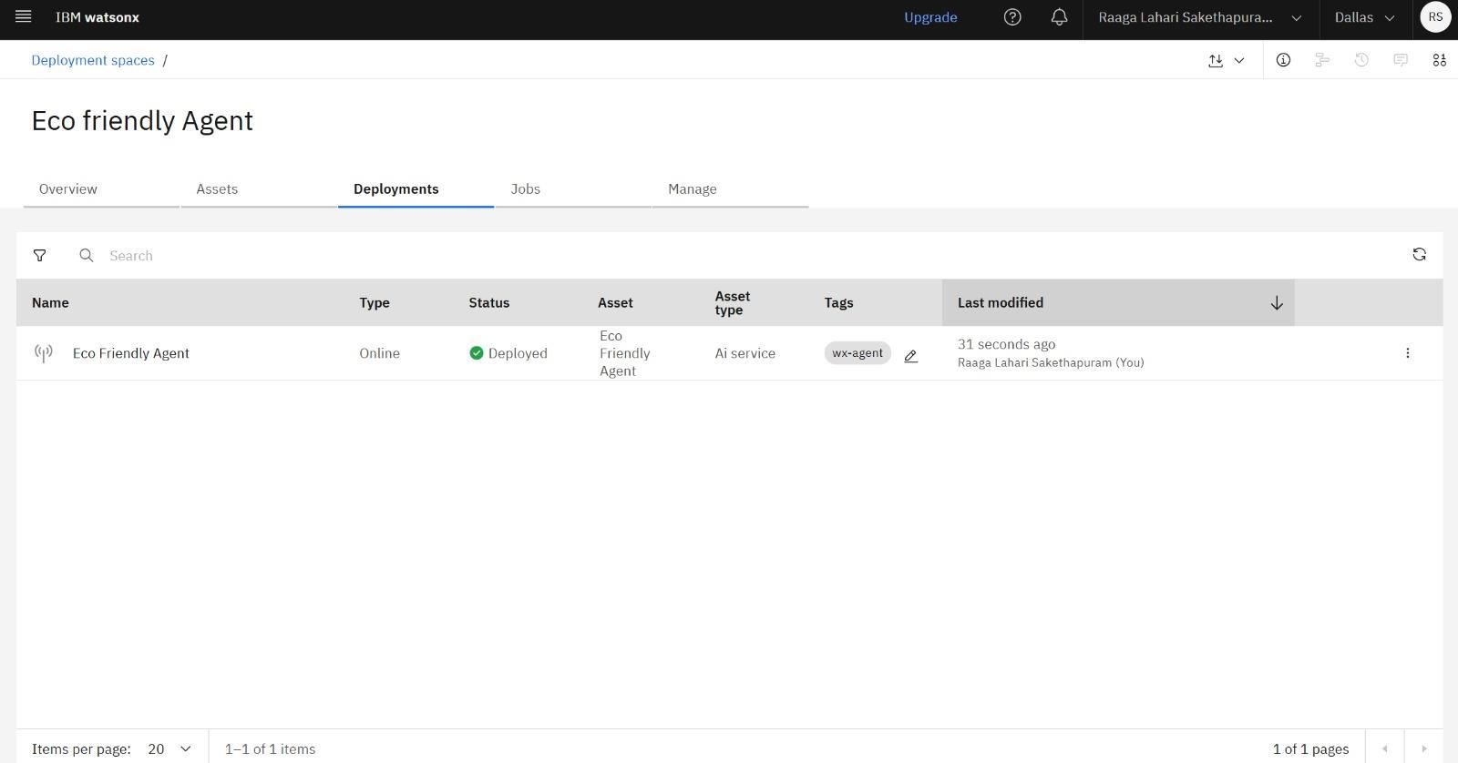

## RESULTS

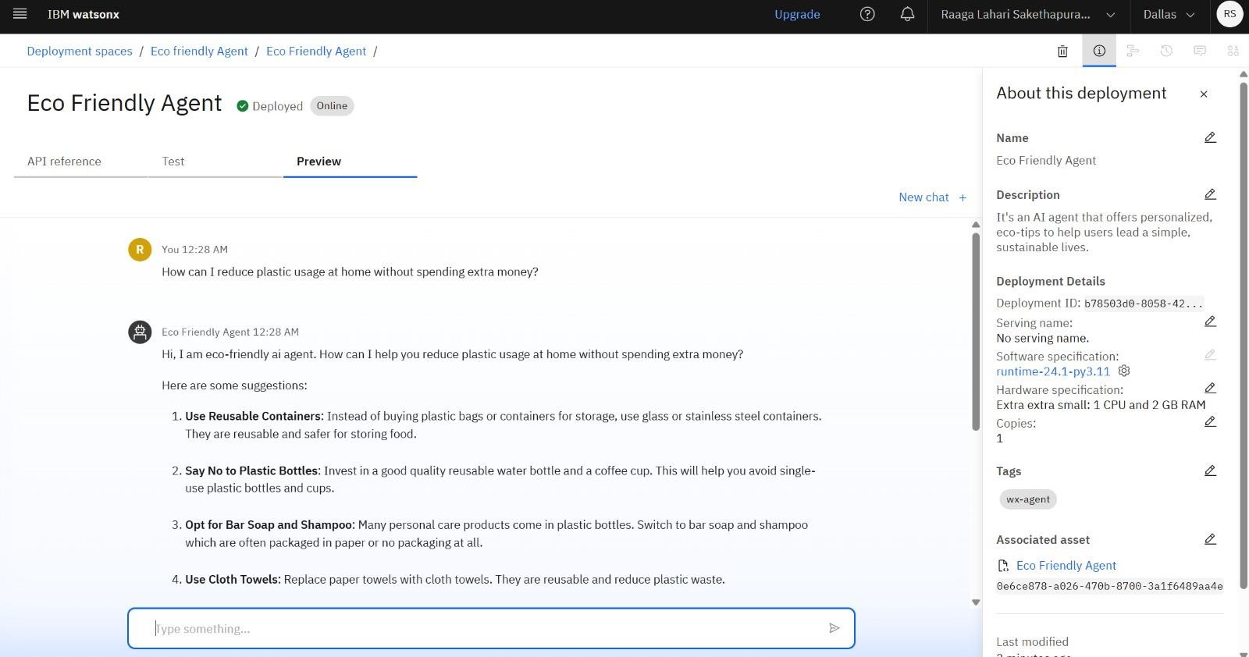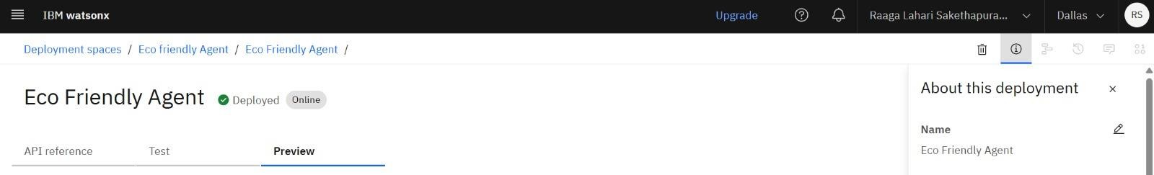

### CONCLUSION

* The Eco Lifestyle Agent bridges the gap between sustainability awareness and action.
* By delivering personalized and localized eco-guidance using IBM Cloud and RAG, it empowers individuals to make small, impactful daily changes for a greener future.

### GITHUB LINK

* <https://github.com/raagalahari/Eco_friendly_AI_Agent>



**FUTURE SCOPE**

* - Multilingual & voice-based assistant
* - Mobile app integration
* - Smart bin sensor data integration
* - Eco habit streaks & gamification
* - Partnership with GHMC, Swachh Bharat, etc.

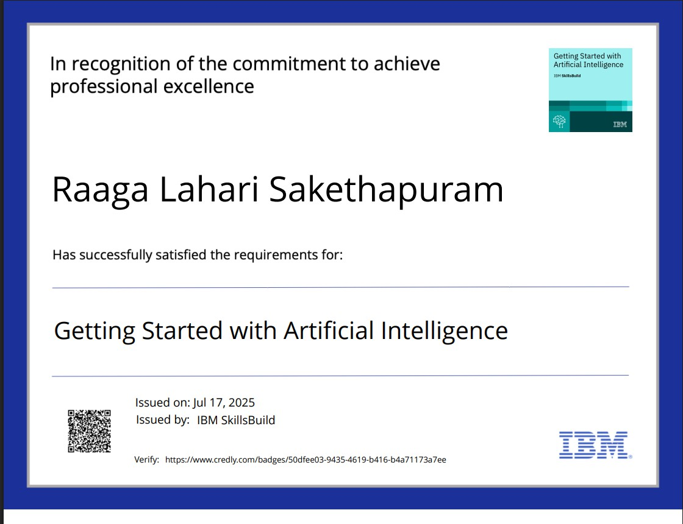

### IBM CERTIFICATIONS

Screenshot (getting started with AI)

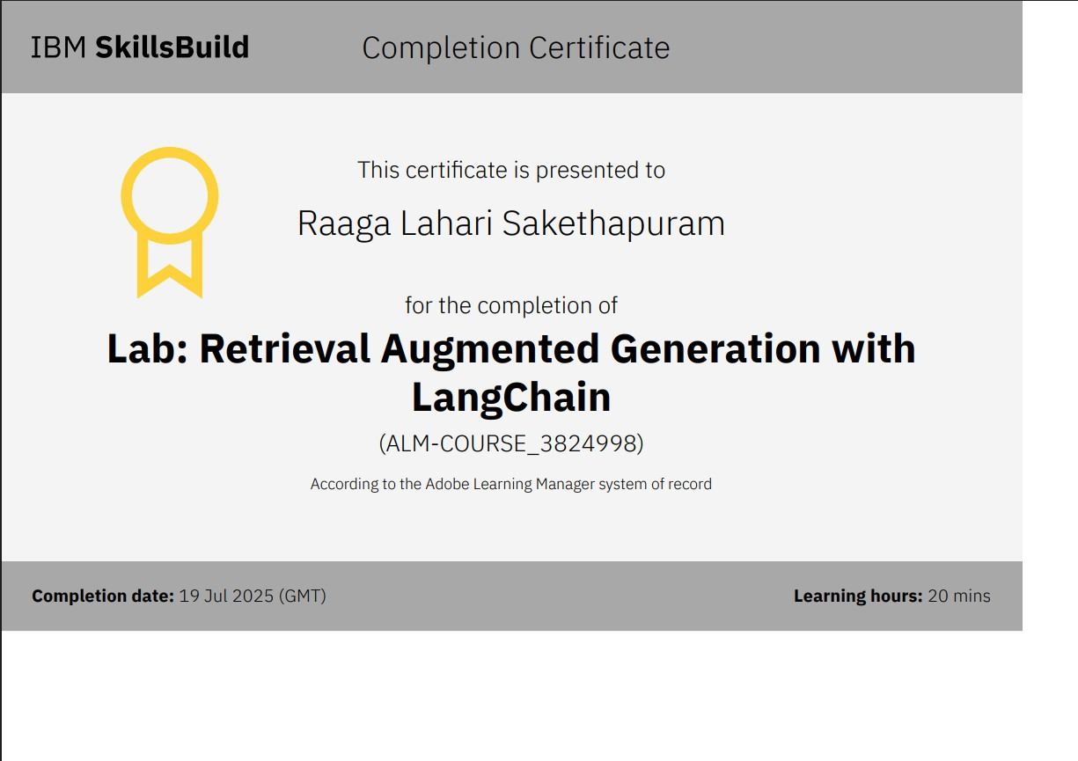

RAG LAB certificate

**THANK YOU**

